Logistic Regression and Newton’s Law

Lab Report #3

|  |  |  |  |
| --- | --- | --- | --- |
| Sidney Carlo P. Lopez (11222522)  sidneylopez18@gmail.com | |  | Jeremy B. Reccion (11210192)  jeremybreccion@yahoo.com |
| Carl Michael O. Sy (11208929)  carl.michael.sy@gmail.com | Wellington S. Villasin (11209534)  wellvill08@gmail.com | | |

*Abstract*— Logistic Regression is a kind of regression that forecast the probability of occurrence of an event by fitting information to a logistic function and Newton's method, additionally called the Newton-Raphson strategy, is a root-discovering calculation.

Keywords—regression; machine; logistic; Newton; method

1. INTRODUCTION

Logistic Regression [1] is a kind of regression that predicts the likelihood of occurrence of an occasion by fitting information to a logistic capacity. In the same way as other types of relapse investigation, it makes utilization of a few indicator variables that may be either numerical or categorical. Case in point, the likelihood that a man shows at least a bit of heart attack inside of a predetermined time period may be anticipated from knowledge of the individual's age, sex and body mass index. This regression is entirely utilized as a part of a few situations, for example, expectation of client's affinity to buy an item or stop a membership in advertising applications and numerous others.

Newton's method [2], additionally called the Newton-Raphson strategy, is a root-discovering calculation that uses the initial few terms of the Taylor series of a function f(x) in the region of a suspected root. Newton's method is otherwise called Newton's iteration, in spite of the fact that in this work the recent term is held to the use of Newton's strategy for computing square roots.

1. OBJECTIVES

* To be able to implement logistic regression on a classification problem using Newton's Method.
* To build a binary classification model that estimates college admission chances based on a student's scores on two exams.

1. EXPERIMENT WITH DATA AND RESULTS

1. Plot of the data.

a. The first column of your x array represents all Test 1 scores, and the second column represents all Test 2 scores.

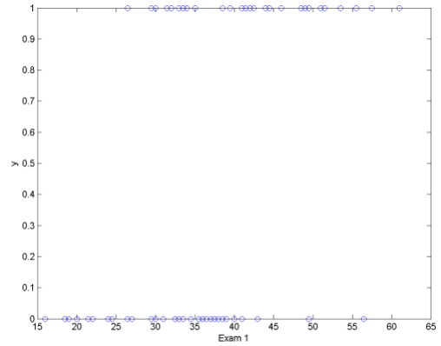

Fig.1. Exam 1 vs. Y plot

b. The y vector uses '1' to label a student who was admitted and '0' to label a student who was not admitted.

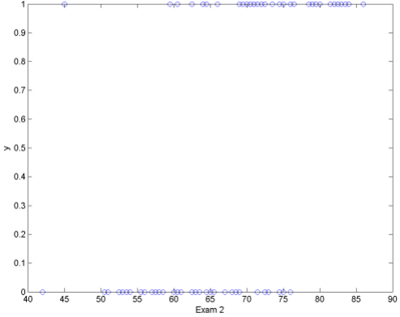

Fig.2. Exam 2 vs. Y plot

2. Plot code.

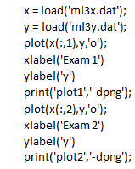

3. Load the data for the training examples into your program and add the x_0 = 1 intercept term into your x matrix.



4. Before beginning Newton’s Method, we will first plot the data using different symbols to represent the two classes. In Matlab/Octave, you can separate the positive class and the negative class using the find command.

a. code

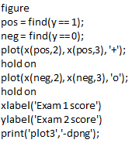

b. data plot

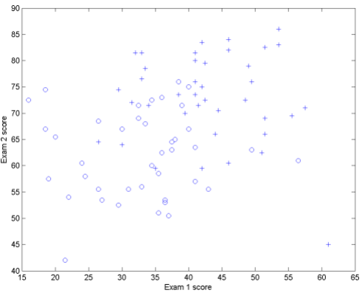

Fig.3. Exam 1 vs. Exam 2 Plot

5. Inline Function.



6. Plot the Cost function J(θ).

a. initialization

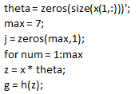

b. gradient



c. hessian



d. cost function J



e. update rule



f. decision boundary

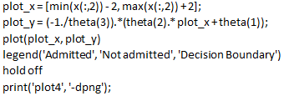

g. code of plot J

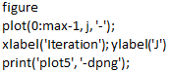

h. plots

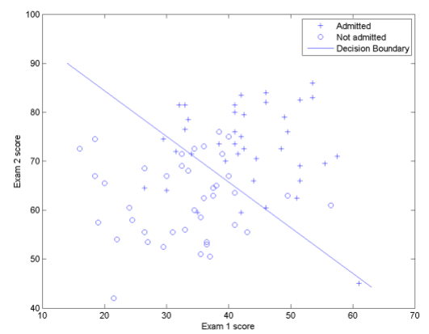

Fig.4. Exam 1 vs. Exam 2 with decision boundary Plot

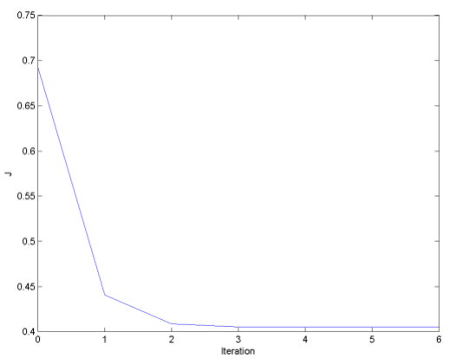

Fig.5. Iteration vs. J Plot

1. QUESTION

Procedure 3.3

1. The final values of θ = ____

𝜃 = [-16.378743410288784; 0.148340773724886; 0.158908451793460]

1. How many iterations were required for convergence?

At least 3 iterations.

3. What is the probability that a student with a score of 20 on Exam 1 and a score of 80 on Exam 2 will not be admitted?

z = [1 20 80] * theta;

g = 1.0 ./ (1.0 + exp(-z));

prob = 1 - g;

prob = Probability = 0.6680

1. PROBLEM

Provide your own.

1. code

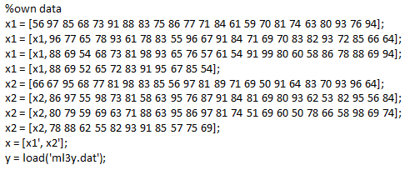

1. plots for procedure 3.1

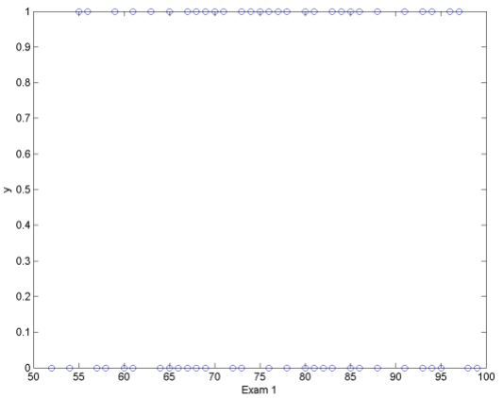

Fig.6. Exam 1 vs. Y plot

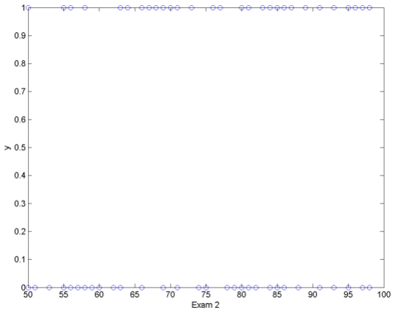

Fig.7. Exam 2 vs. Y plot

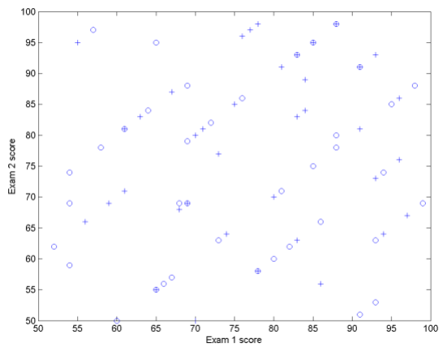

Fig.8. Exam 1 vs. Exam 2 plot

1. plots for procedure 3.2

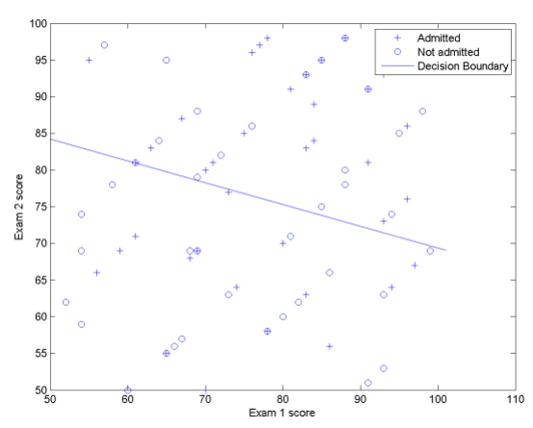

Fig.9. Exam 1 vs. Exam 2 with decision boundary plot

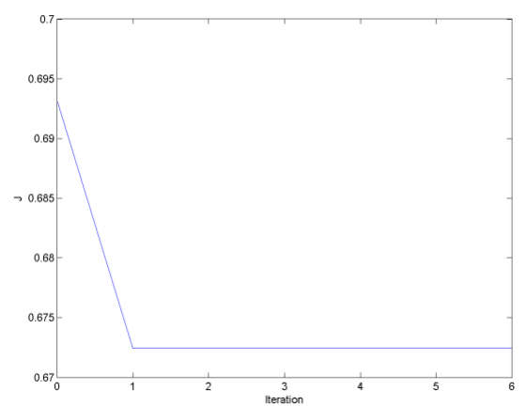

Fig.10. Iteration vs. J plot

1. procedure 3.3
2. The final values of θ = ____

𝜃 = [-2.780973275207656; 0.008336757961670; 0.028063257347149]

1. How many iterations were required for convergence?

At least 1 iterations.

1. What is the probability that a student with a score of 20 on Exam 1 and a score of 80 on Exam 2 will not be admitted?

z = [1 20 80] * theta;

g = 1.0 ./ (1.0 + exp(-z));

prob = 1 - g;

prob = Probability = 0.5913

1. ANALYSIS AND CONCLUSION

REFERENCES

[1] Aimotion.blogspot.com, 'Machine Learning with Python - Logistic Regression - Artificial Intelligence in Motion', 2011. [Online]. Available: http://aimotion.blogspot.com/2011/11/machine-learning-with-python-logistic.html. [Accessed: 22- Sep- 2015].

[2] Mathworld.wolfram.com, 'Newton's Method -- from Wolfram MathWorld', 2015. [Online]. Available: http://mathworld.wolfram.com/NewtonsMethod.html. [Accessed: 22- Sep- 2015].

[3] Machine Learning of Stanford, OpenClassroom by Andrew Ng

(<http://openclassroom.stanford.edu/MainFolder/DocumentPage.php?course=MachineLearning&doc=exercises%2Fex3%2Fex3.html>)